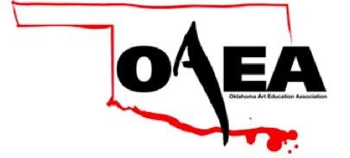
Dear vendors, please indicate how many tables you will be needing for your participation at the Oklahoma Art Education Fall Conference at The University of Tulsa Saturday September 30th, 2017. We are looking forward to meeting you! OAEA has a room reserved “The Mary Kay Chapman Great Hall A” in the student union for the conference. You will be able to set up either Friday or Saturday and your merchandise will be secure. The University is providing the tables and the table clothes at no cost.

- ____ One table.

- ____ Two tables.

- ____ Will provide your own table/booth.

____ Will you send packet materials? (approx. 150 – 200)

YOU MUST FURNISH YOUR OWN VERTICAL PANELS FOR DISPLAY EXHIBITOR COMPANY: _____________________________________________
PHONE NUMBER: ________________________________________
EMAIL ADDRESS:________________________________________
CONTACT PERSON: ______________________________________
RETURN TO: School of Art C/O Lora Hodge
The University of Tulsa
800 S. Tucker Dr.
Tulsa, OK 74104
(918) 631-2739

*All supplies can be sent directly to the address above

Hotel rooms are available for Friday night, but make arrangements as soon as possible for the reduced rate. Mention “OAEA” when booking over the phone.

Fairfield Inn 111 N. Main St., Tulsa, OK (918) 879-1800 $ 109 + tax (2 beds per room) Offer expires on September 7, 2017

Hyatt Regency 100 E. 2nd St., Tulsa, OK (888)-735-2954 $ 91 + tax (2 beds per room) Offer expires on August 31, 2017

